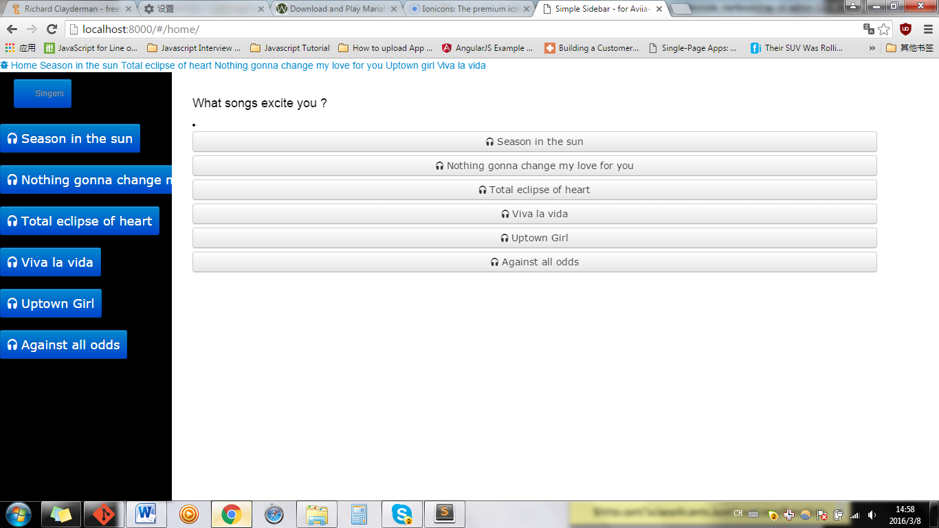

The above, singer is a link (a href)

As singer is a link, others are button

<li class="sidebar-brand">

**<a href=”” class="btn btn-info btn-primary">**

**Songs**

**</a>**

</li>

**RIGHT**

<li class="sidebar-brand">

**<button class="btn btn-info btn-primary">**

**Songs**

**</button>**

</li>

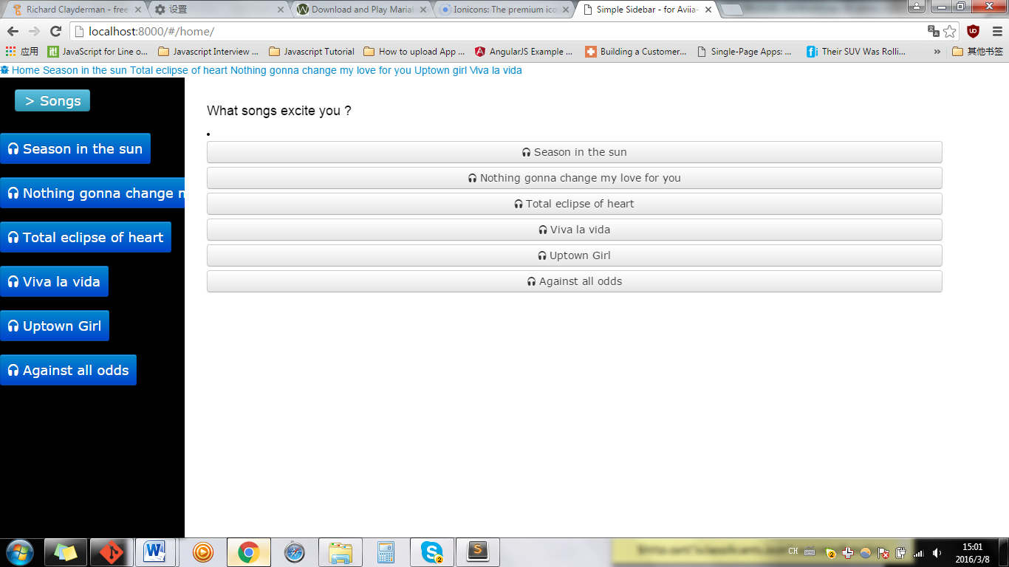

BUTTON